Day 8 Coding Assignment — Indexing, Aggregation, and MongoDB Atlas
Scenario Background
BookVerse is now scaling, and you are tasked with optimizing database performance and enabling analytics using MongoDB’s advanced features. You will implement indexes, run aggregation pipelines, and connect your local database to MongoDB Atlas.
User Story 1 —
Indexing and Query Optimization As a developer, I need to optimize frequently used queries to improve database performance.
Tasks:
1. Identify frequently queried fields (e.g., genre, authorId, ratings.score).
2. Create indexes on these fields using the createIndex() method.
3. Compare query performance using the explain("executionStats") command before and after creating indexes.
4. Drop an unnecessary index using dropIndex() and note its impact.
Concepts Covered: Indexing, query optimization, performance analysis
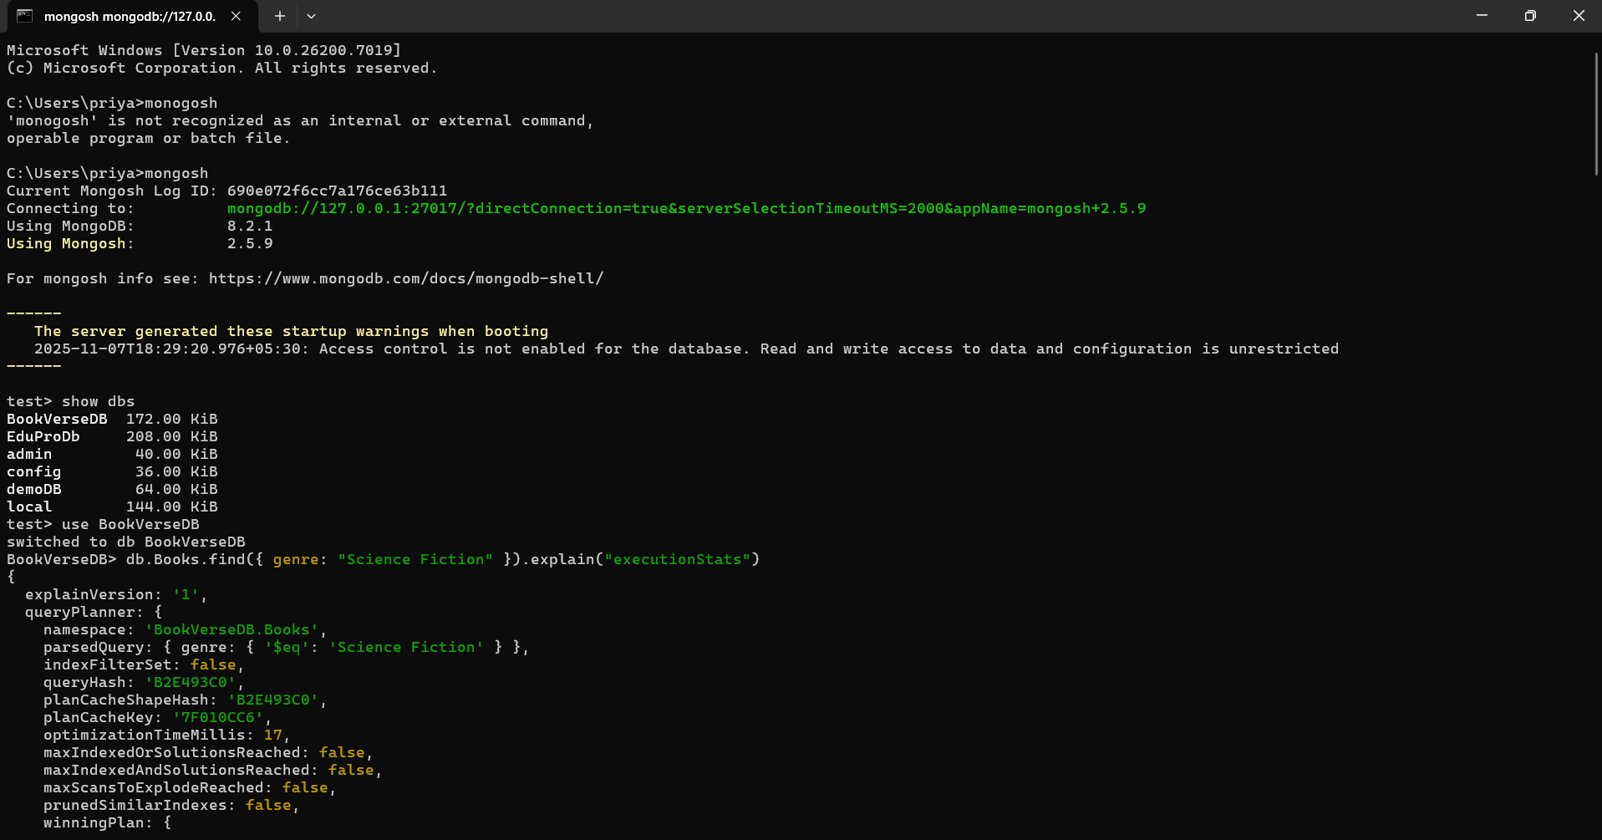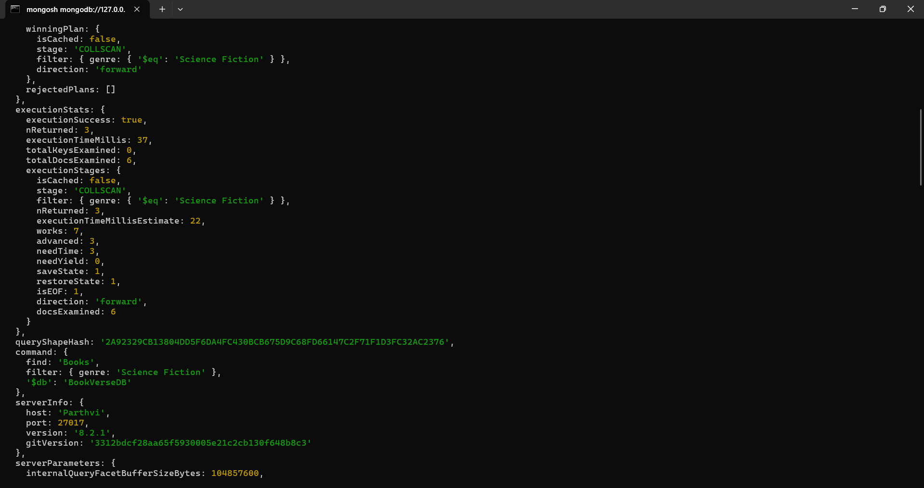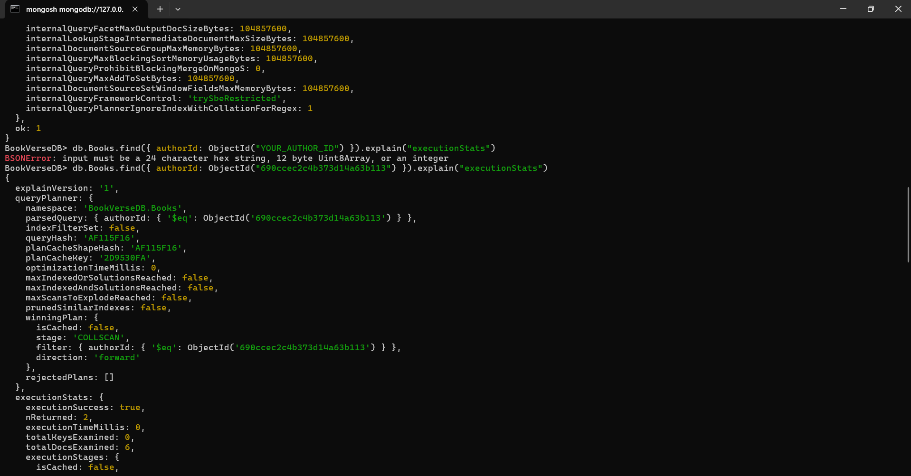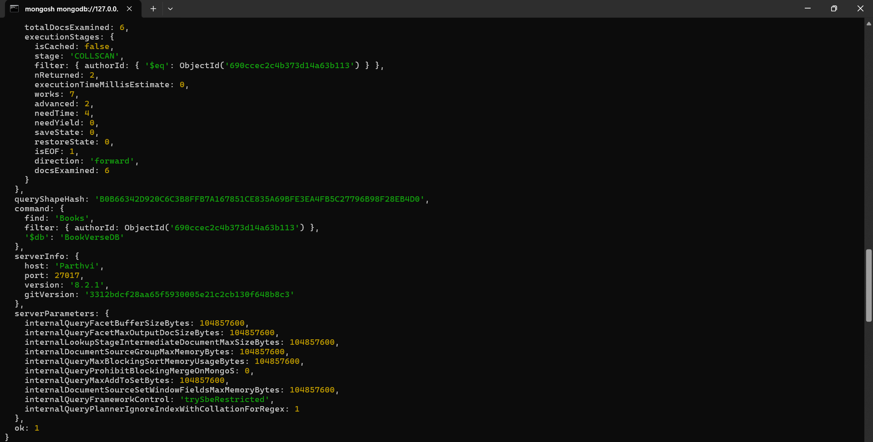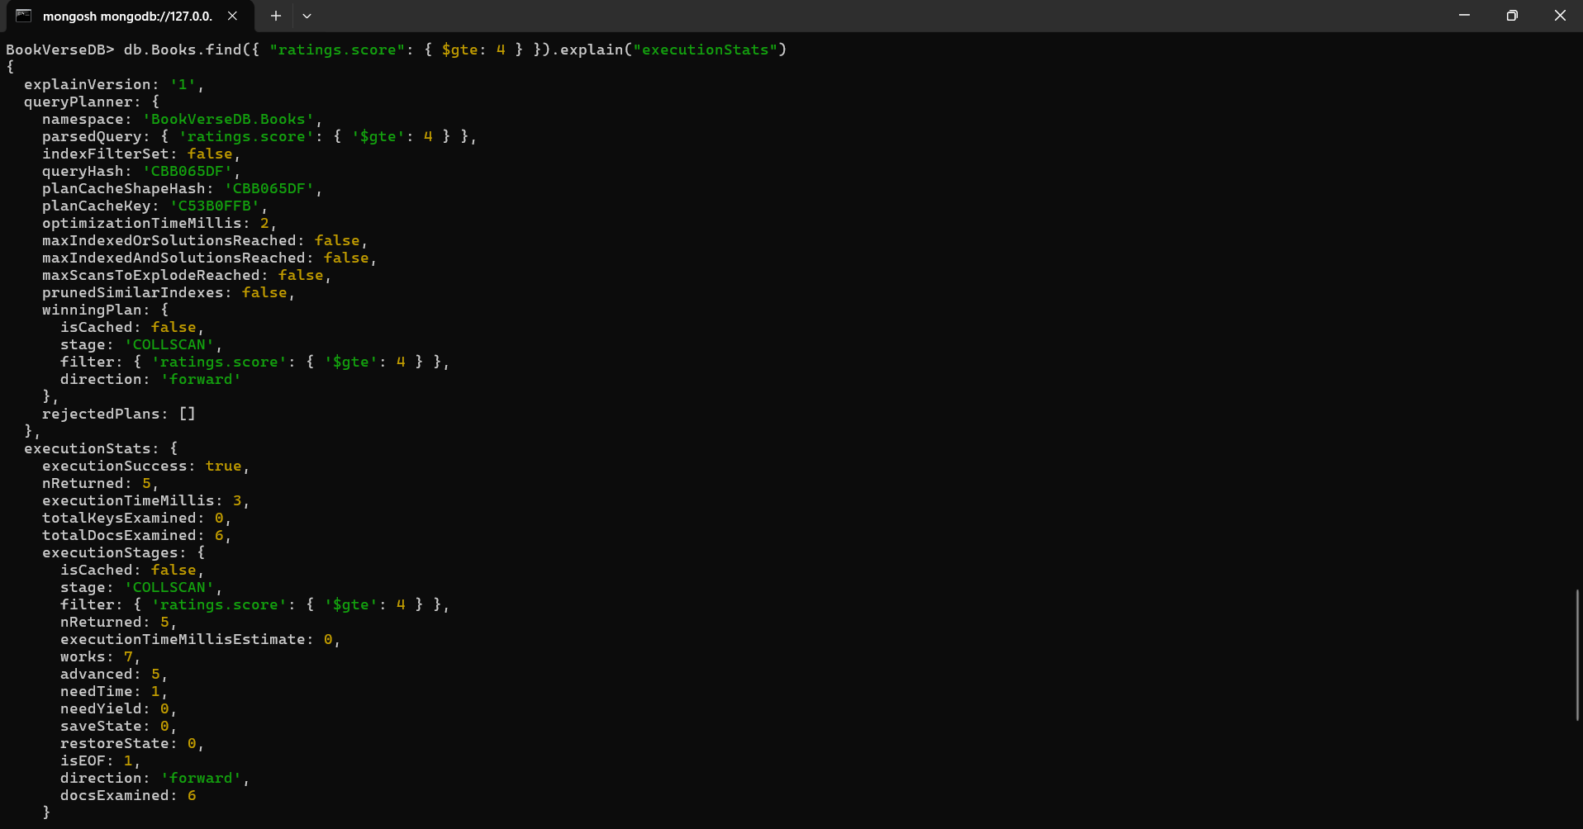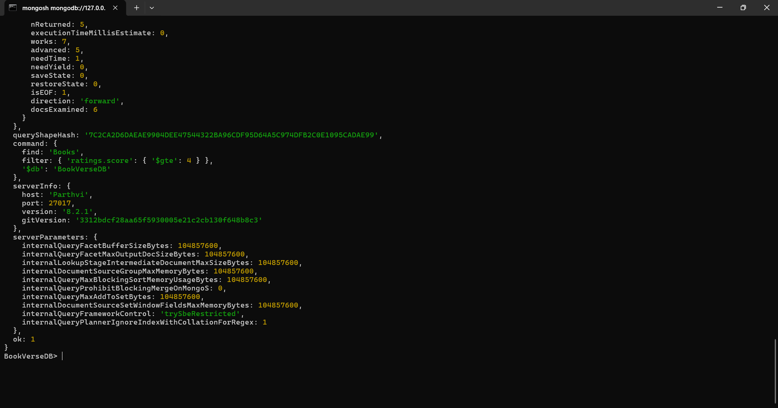

After Creating Index

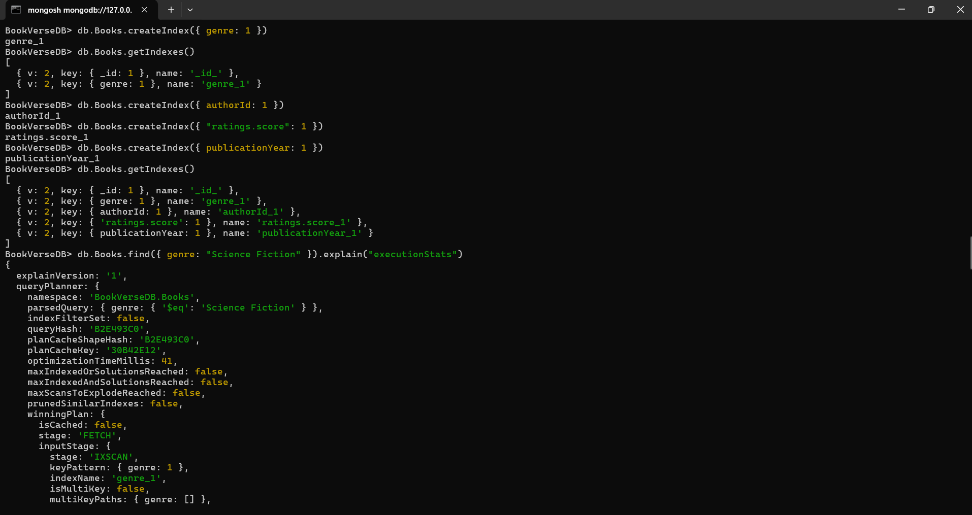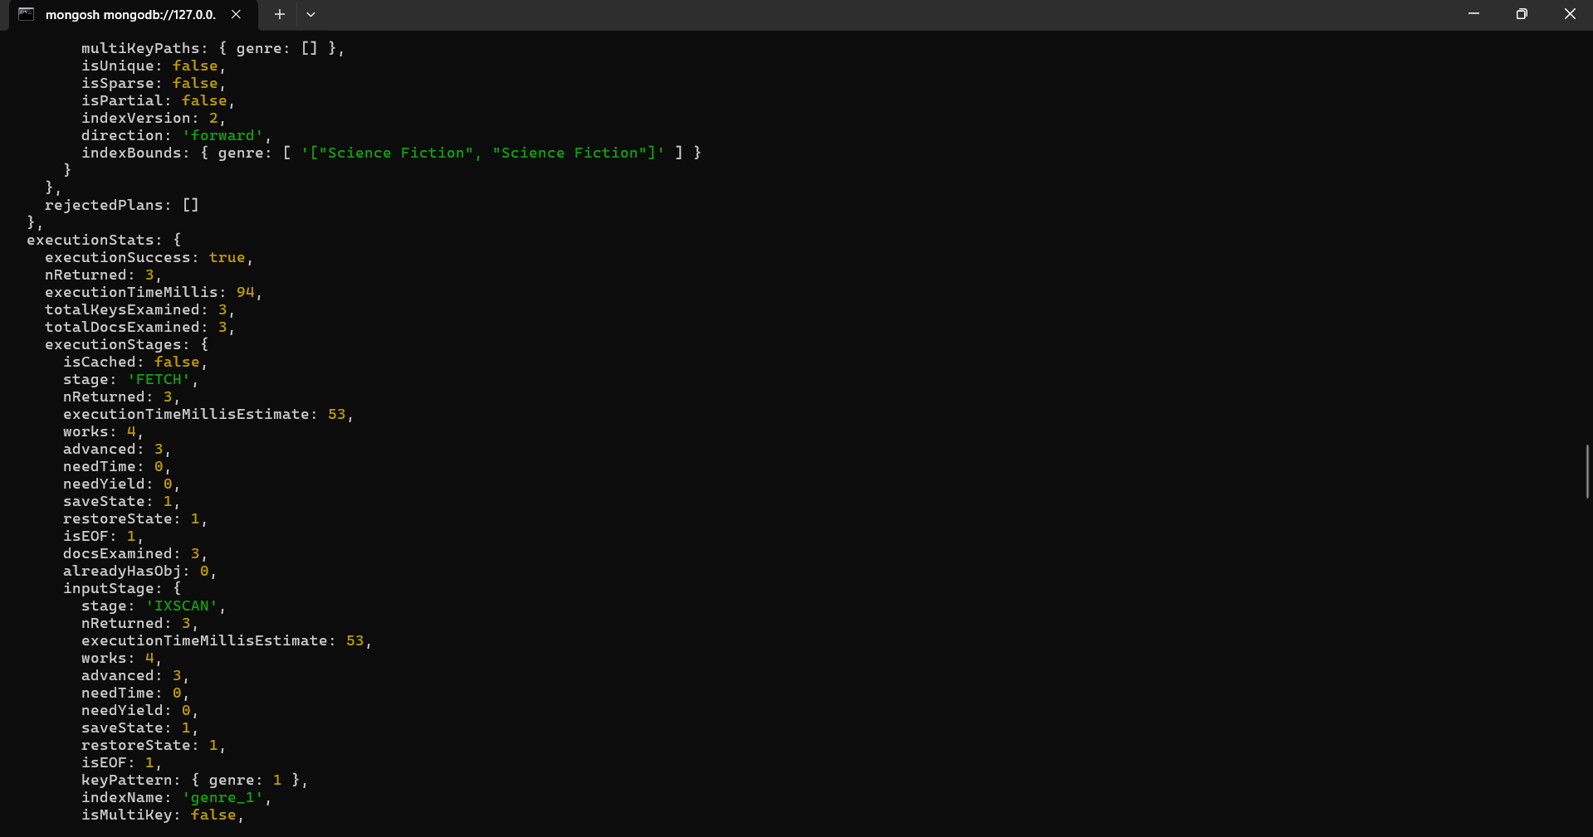

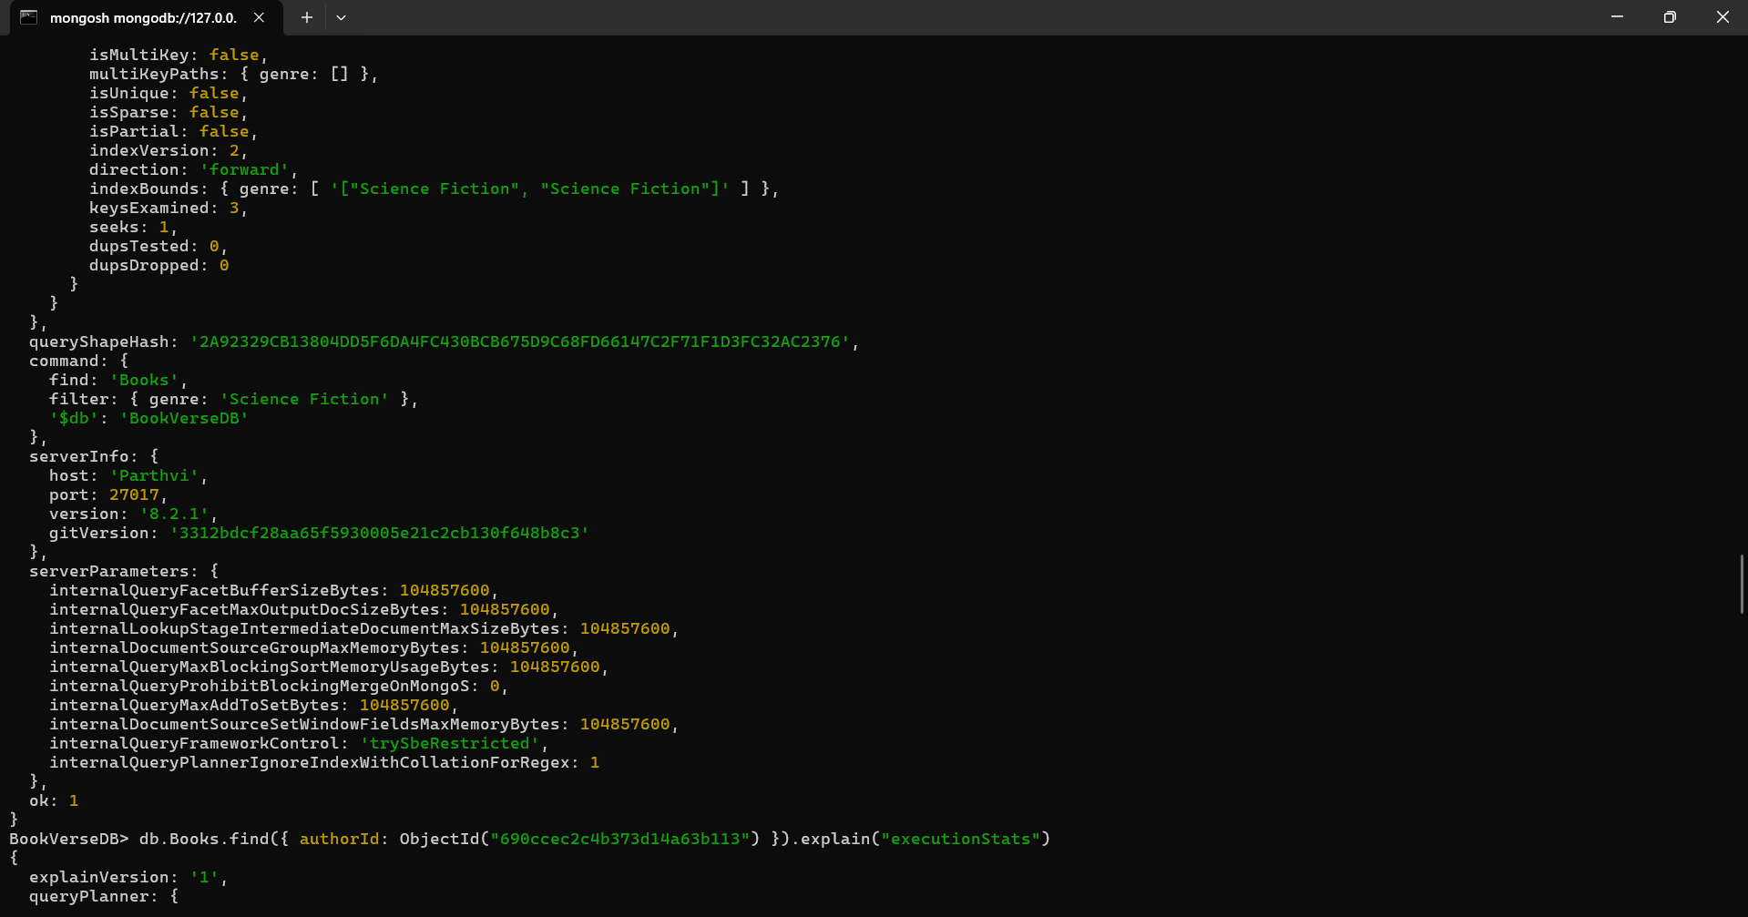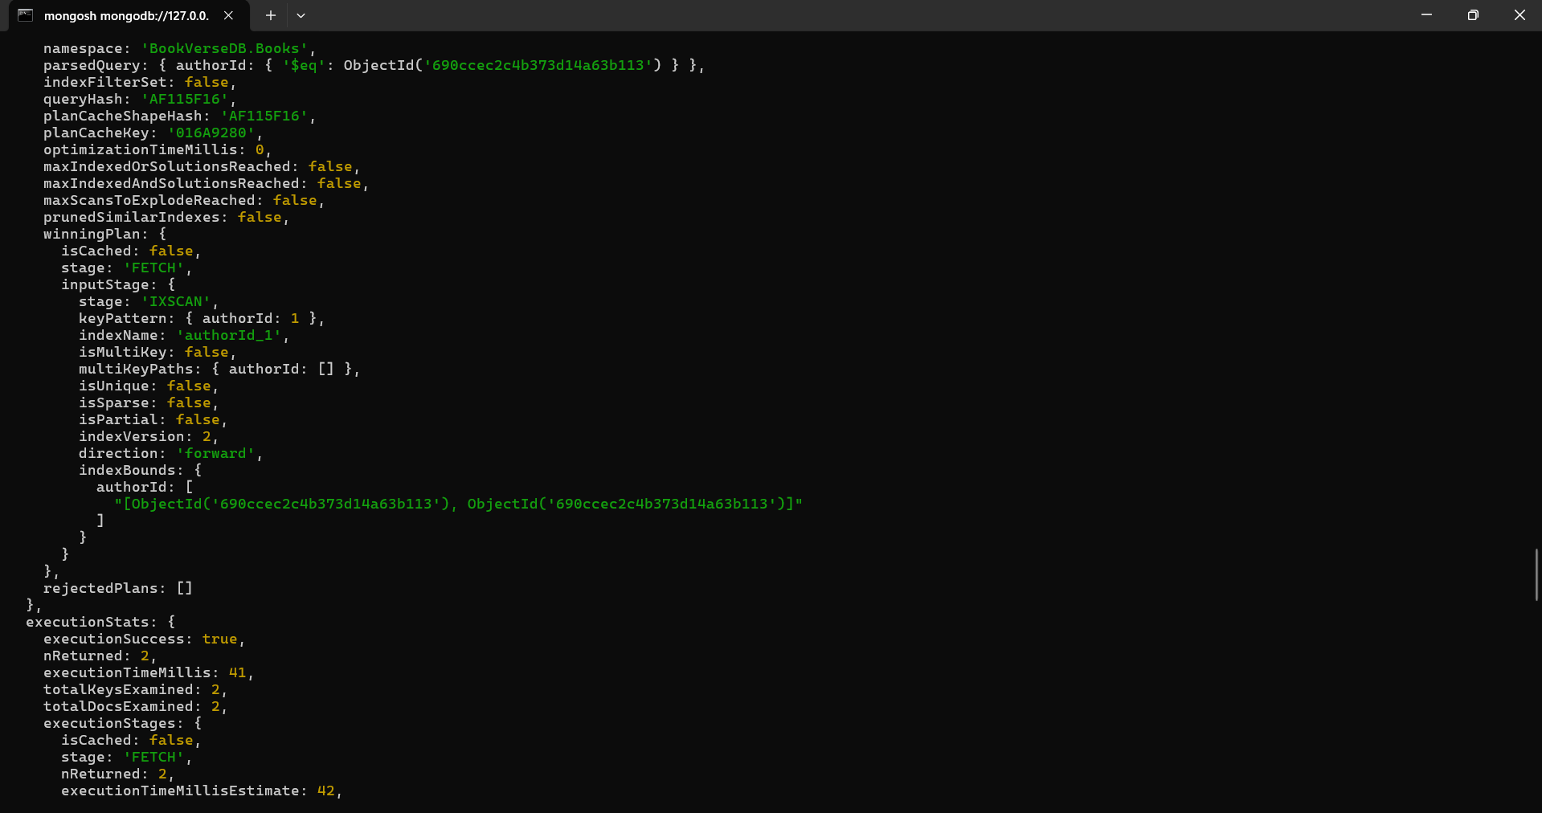

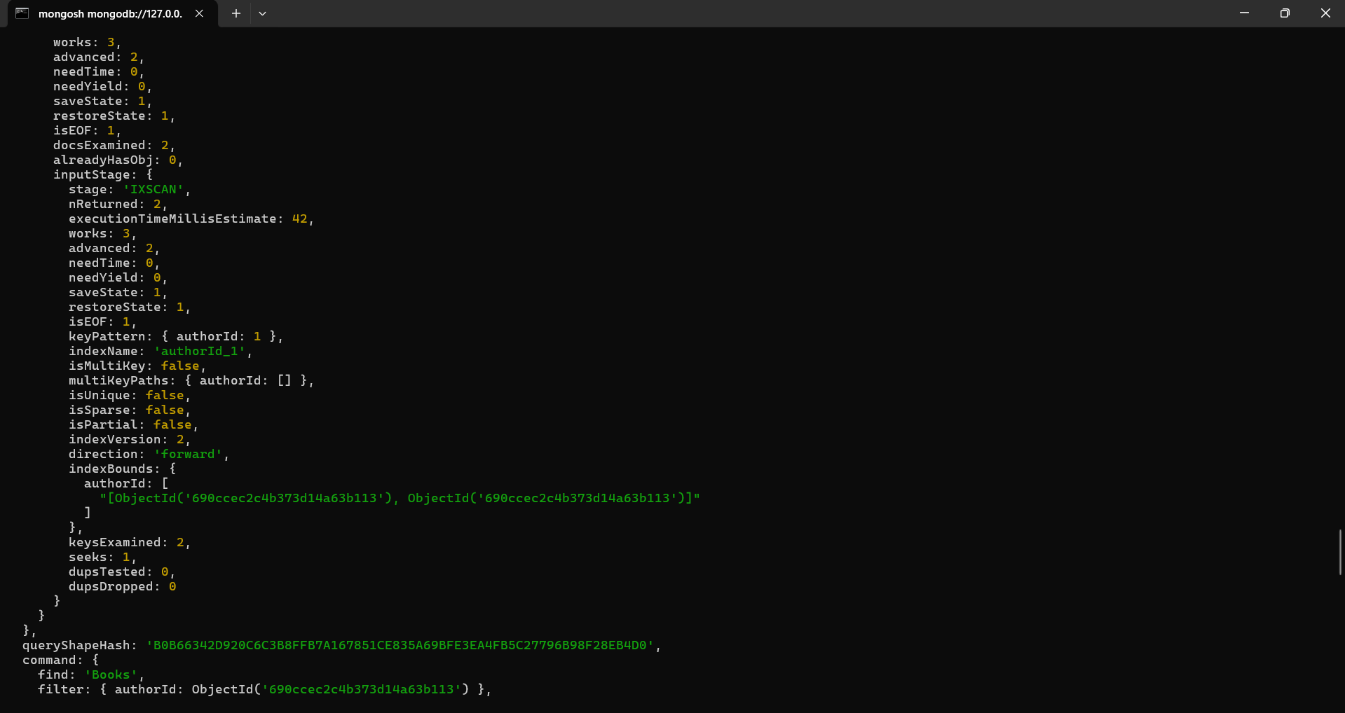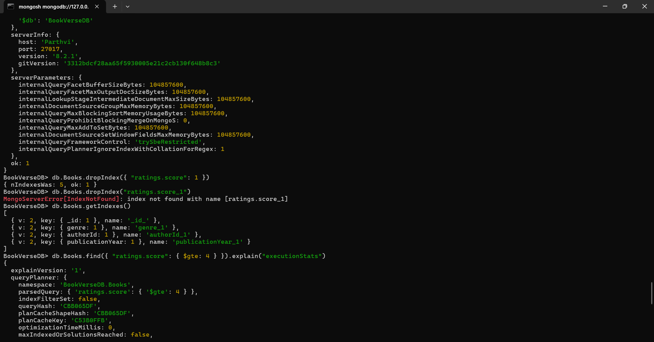

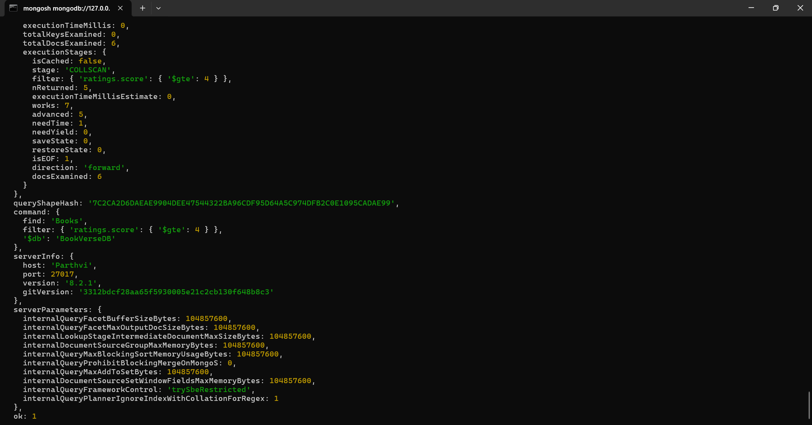

User Story 2 —
Aggregation Framework As a data analyst, I need to generate reports about books and their ratings using MongoDB’s aggregation pipeline.
Tasks:
1. Calculate the average rating per book using $unwind, $group, and $avg.
2. Retrieve the top 3 highest-rated books.
3. Count the number of books published per genre.
4. Find authors who have more than 2 books published.
5. Display the total reward points (sum of all ratings) received by each author.
Concepts Covered: Aggregation stages, grouping, projection, sorting

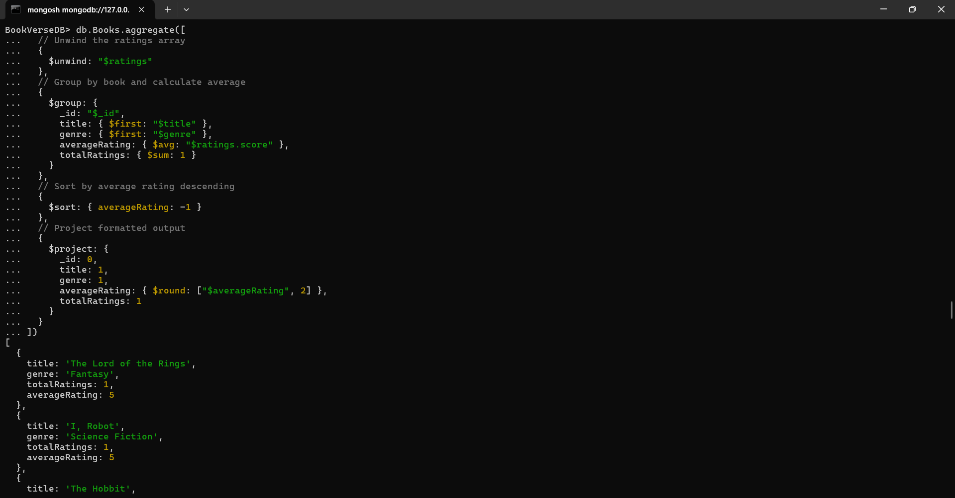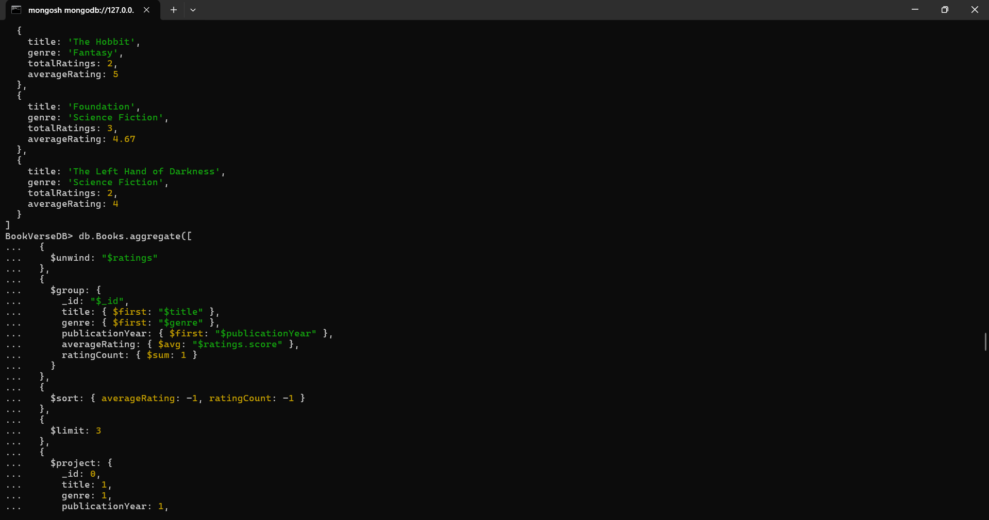

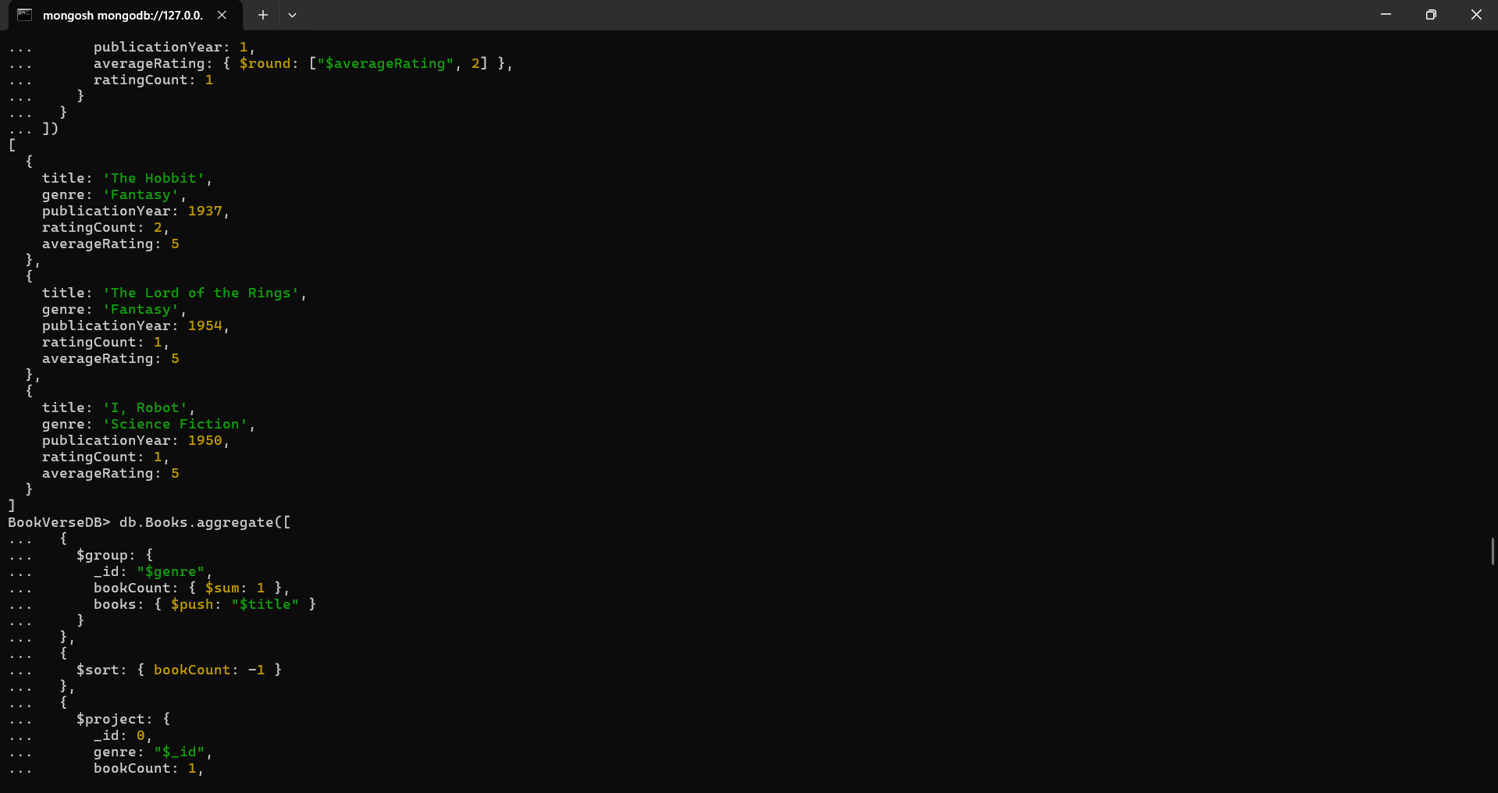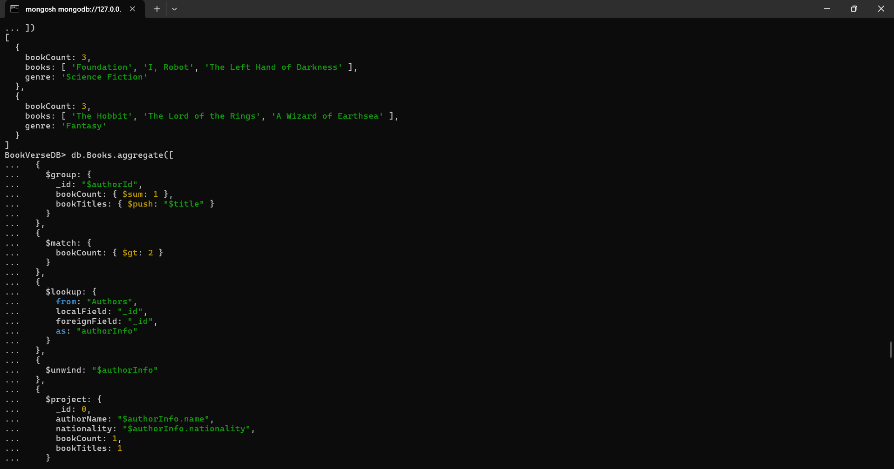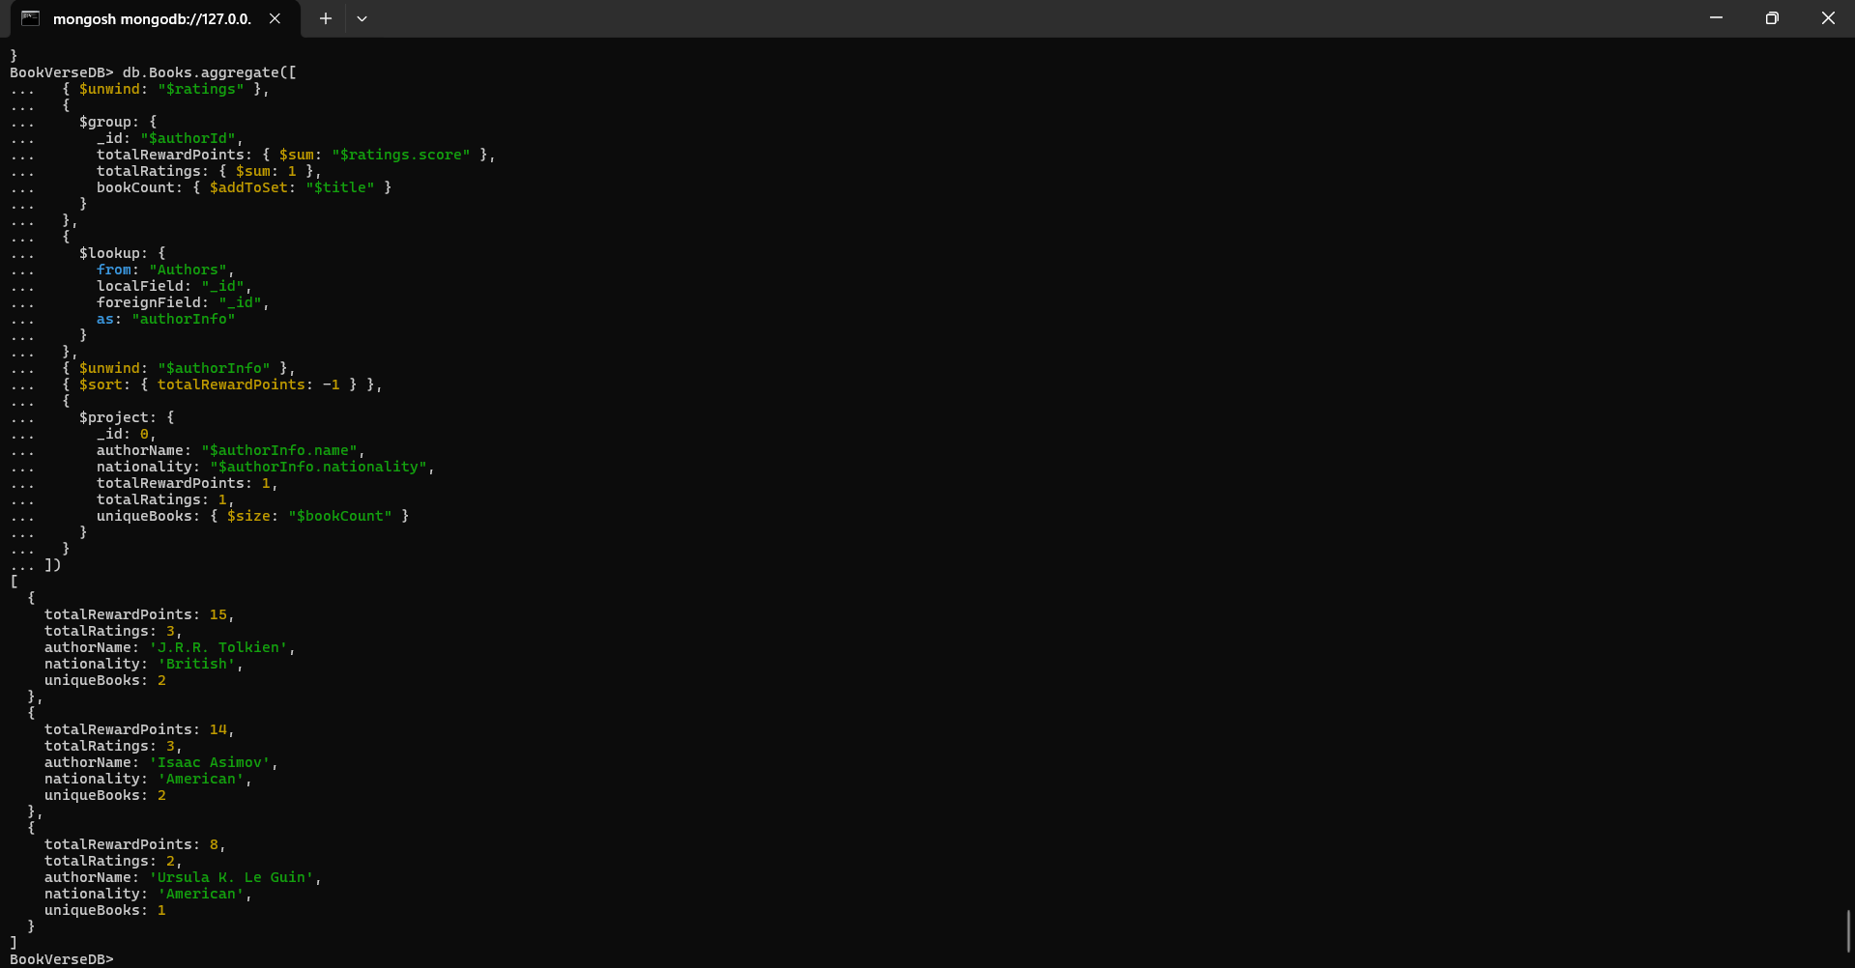

User Story 3 —
MongoDB Atlas Connection As a backend engineer, I need to deploy and connect the database to MongoDB Atlas for cloud management.
Tasks:
1. Create a free cluster in MongoDB Atlas.
2. Create a database named BookVerseCloudDB.
3. Import your local collections (Authors, Books, Users) into Atlas.
4. Connect to your cluster using the connection string in a Node.js script or MongoDB Compass.
Concepts Covered: Cloud database setup, connection configuration, data import
